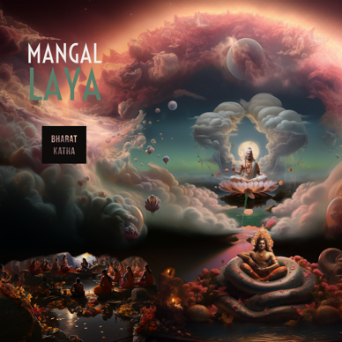

FOR IMMEDIATE RELEASE

Mangal Laya: A Global Celebration of Cultural Fusion and Musical Brilliance.

UNITED KINGDOM – Mangal Laya, a musical revelation blending the rich cultural tapestry of Uttarakhand with the pulsating beats of London breakbeat, is set to captivate audiences worldwide. This dynamic composition promises a transcendent musical journey, transcending genres and celebrating the spirit of diverse traditions.

Synopsis
Released on all streaming platforms, Mangal Laya introduces intensified breaks, deep bass, and emotional vocals, reflecting the song's dynamic evolution. The fusion of cultural elements creates a harmonious experience that resonates globally, bridging continents through the universal language of music.

In the Mangal section, Mangal Laya delves into the heart of the Harvest festival, where villagers unite to celebrate the first harvest with traditional Uttarakhand dishes. The soul-stirring Mangal Bhavan Amangal Haari bhajan, sung by women during this festive occasion, adds a spiritual depth to the composition. This stanza, a prayer to Bhagwan Ram, invokes divine blessings for auspiciousness and the removal of inauspicious elements.

The Laya segment, featuring Heera Balabh Joshi's performance of a fagaar traditional wedding song, portrays a bride's heartfelt plea for respect, drawing parallels to the divine reverence given to Bhagwan Brahma. Symbolic gestures, such as holding a bronze pot filled with water towards her navel, further enhance the cultural richness of the song.

Acknowledged on Radio 6 by the esteemed Tom Robinson and featured on BBC Introducing and BBC Sounds, Mangal Laya transcends its status as a mere song. It becomes a cultural celebration echoing beyond borders, uniting listeners across the globe.

Music Review

Michael White
(Engineer- Right Track Recording Studios, Jimi Hendrix's Electric Lady Studios, Solid State Logic, Outdoor Life Network, and Sirius Satellite Radio. worked on albums for Whitney Houston, James Taylor, Rolling Stones, Talking Heads, David Bowie, 3 Doors Down, and others.)

Really super cool track! Keep working the way you are working because it’s getting great results.

Tom Robinson singer, and BBC Radio 6 Host.

Oddly, brilliant!

For media inquiries, please contact:

Nitin Krishen
nitin@bharatkatha.com
www.bharatkatha.in
www.instagram.com/bharatkatha

About the Artist

Nitin Krishen is a visionary musician dedicated to bridging cultures through the universal language of music. Mangal Laya stands as a testament to his commitment to crafting compositions that celebrate diversity and unite global audiences.

Nitin Krishen, an Indian born London-based artist known for his vivid and vibrant storytelling that combines his unique perspective and the essence of his eastern and western lives, with just a touch of splendid eccentricity.

Listen Now

Mangal Laya is available on Spotify, Apple Music, YouTube and others. Experience the cultural fusion and musical brilliance that define this unique masterpiece.
Stream Now

Follow Bharat Katha

Connect with Bharat Katha on Instagram, Facebook for the latest updates, releases, and behind-the-scenes insights into the creative process.

www.instagram.com/bharatkatha
www.facebook.com/bharat.katha

